Quantifying the Value of Upgrade Options for Biogas Cogeneration
Madison, Wisconsin, turns to the consulting arm of Autocase to
inform best paths towards district-wide energy independence.

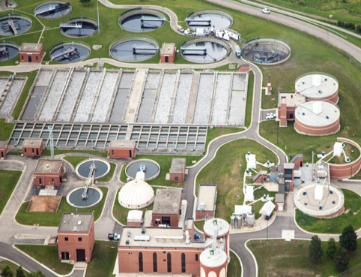
Challenge: The Madison Metropolitan Sewerage District (MMSD) has a long history of using recovered resources including digester biogas and heat to reduce the resource requirements at its Nine Springs Wastewater Treatment Plant (NSWWTP). As part of a Capital Improvement Plan, MMSD’s strategic objective was to optimize biogas production towards the goal of energy independence for the District.

To ascertain which paths towards local electricity production were most cost- effective financially and valuable societally, MMSD consulted with engineering firm Brown and Caldwell who developed four options for consideration, each of which would be compared to a baseline case.
All five options (see chart) produced the same amount of biosolids but differed in the level of power production, the energy to dry biosolids, the volume of biosolids hauled and disposed, and the electricity and natural gas required to operate the new system. MMSD could easily measure the difference in performance characteristics between the five options, but what would be the basis for their choice of one versus the other—upfront cost, energy independence, or something more comprehensive?
Baseline | $500,000 initial capital outlay, $24,000 in annual maintenance and 11,000,000 kWh of electricity production
Option 2 | Replace existing engines with similar co-generation units
Option 3 | Replace existing engines with centralized co- generation engines using internal combustion (IC) engine-generators with heat recovery
Option 4 | Replace existing engines with centralized co- generation engines using an Organic Rankine Cycle (ORC) system
Option 5 | Add an electric blower drying system for class A biosolids
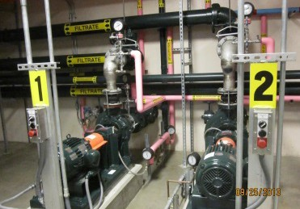
Solution: Autocase’s consulting arm provided the methodology by which MMSD could compare all options on a common, monetized basis: Triple Bottom Line Cost Benefit Analysis (TBL-CBA). TBL-CBA is a systematic evidence-based economic business case framework that uses best practice Life Cycle Cost Analysis (LCCA) and Cost Benefit Analysis (CBA) techniques to quantify and attribute monetary values to the
Triple Bottom Line (TBL) impacts resulting from an investment. TBL-CBA expands the traditional financial reporting framework (such as capital, and operations and maintenance costs) to take into account social and environmental performance.

ON METROPOLITAN
SEWER DISTRICT
Energy Baseline and
Optimization Roadmap
- Informed the Capital Improvement Plan (CIP)
- Analyzed 5 biogas process options that considered
- Increased heat and power production
- Reduced biosolids hauling
- Applied Cost-Benefit
Analysis (CBA) across
financial, social and environmental impacts
for an expanded, Triple
Bottom Line (TBL) valuation
of alternatives

The consulting team quantified and monetized a variety of impacts related to:

  - Electricity and Natural Gas Purchases
  - Biosolids Disposal Cost Savings
  - Capital & Replacement Costs
  - Operations and Maintenance Costs
- Residual Value of Assets
- Greenhouse Gas Emissions
- Criteria Air Contaminant Emissions
- Trucking Externalities

And presented risk-adjusted Net Present Value (NPV) results over a long term study period to identify the lifecycle costs
and broader social and environmental tradeoffs between the options. From a financial lifecycle cost perspective, Option 5 was clearly the least costly. However, the TBL-CBA assessment also highlighted how Option 5 would increase MMSD’s dependence on the electric grid in order to operate an additional electric blower.
The upgraded co-generation systems in Option 3, on the other hand, would offset 8 million kWh of electric demand,
thereby generating significant electricity savings. In addition, because the electric grid from which MMSD would otherwise draw outside power is heavily dependent on coal, the greenhouse gas (GHG) emissions from the co-generation process would shrink dramatically, thereby contributing to an additional social benefit of $7.7 million based on a risk- adjusted cost of carbon of $45.73.
Outcome: For MMSD, the TBL-CBA assessment drove home the importance of their strategy for energy
independence by capturing the extent to which this would contribute to both hard and soft dollar savings.

 | Financial NPV |  | Social &  Environmental NPV |  | Triple Bottom Line NPV | Triple Bottom Line BCR
OPTION 2: Replace engines with similar co-gen units,  maintain boilers | ($8,765,374) | + | $2,720,215 | = | ($6,045,159) | 0.56
OPTION 3: Centralized co-  gens using IC engines | ($5,900,823) | + | $9,009,128 | = | $3,108,304 | 1.14
OPTION 4: Centralized co-  gens plus ORC system | ($13,532,334) | + | $4,449,184 | = | ($9,083,151) | 0.78
OPTION 5: Drying class A  biosolids | ($4,370,615) | + | ($3,605,977) | = | ($7,976,593) | 0.27

Overall, the results indicated that most options had considerable incremental social and environmental benefits as the result of reduction in electric grid demand, but only Option 3 generated a positive incremental TBL return—where the social and environmental benefits outweighed the financial costs, and the benefit-cost ratio was greater than 1.
In the end, TBL-CBA provided the District with an approach for developing an objective, transparent and defensible economic case. For MMSD, this would help advise their Capital Investment Plan with the benefits of all stakeholders in mind.

Autocase: Making the business case for infrastructure projects.

A complex project can be both costly and time consuming. Why not have our experienced
economists take some of that burden off of you and run the analysis for you? Our breadth of
service includes: Triple Bottom Line and Cost Benefit Analysis; Financial and Life Cycle Cost
Analysis; Economic Impact Analysis; Risk and Cost Risk Analysis; Sustainable Return on
Investment; and Cross Asset Strategic Planning – all across a wide range of sectors.

For more information about how TBL-CBA would assist your project, go to www.autocase.com

